**Summer**

**Year 1 Planning**

‘STAND OUT’

**Science**

We will be identifying evergreen and deciduous trees.

We will be naming a variety of common wild and garden plants.

We will be sorting and classifying evergreen and deciduous trees.

We will be identifying wild plants and flowers.

We will be identifying garden plants and flowers.

**Activity**

We will be planting beans.

**History**

We will be researching the lives of individuals from the past and comparing aspects of life in different periods.

We will be researching events beyond living memory that are significant nationally or globally

We will be researching significant historical events, people and places in their own locality.

**Activity**

We will compare Queen Elizabeth II to Queen Victoria.

We will visit the Victorian School museum in Hull.

We will learn about the Great Fire of London.

We will learn about the life of William Wilberforce and the slave trade.

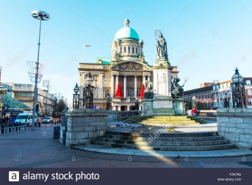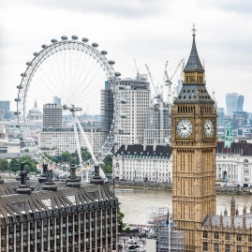

**Music**

We will use our voices to speak, sing and chant.

We will clap short rhythmic patterns.

We will make different sounds with our voices.

We will make a sequence of sounds.

We will say whether I like or dislike a piece of music.

We will play and sing about when to play and sing.

We will respond to different moods in music.

**Activity**

We will use Charanga.

**DT**

We will use our own ideas to build our product.

We will cut food safely.

We will explain to someone else how we want to make our product.

We will choose appropriate resources and tools.

We will make a simple plan before making.

We will evaluate our product.

**Activity**

We will make pumpkin soup (linked to literacy).

**London to Hull**

**Projects**

**LAUNCH:** Royal Afternoon Tea, children dressed as kings and queens (linked to history).

**TRIP:** Hull Victorian Museum

**CELEBRATION:** Display of landmark sculptures.

**Art**

We will research a famous artist who creates sculptures.

We will cut, roll and coil materials

We will describe what we can see and give an opinion about the work of an artist.

We can ask questions about a piece of art.

#### Activity

Creating sculptures of Hull/London famous landmarks.

**PE**

IPEP - Ball control

Athletics

# **Geography**

We will use aerial photographs and plan perspectives to recognise landmarks and basic human and physical features.

We will be creating instructions and directions on how to move around the map.

We will use a compass to plan a journey from Hull to London.

**Activity**

Drawing routes on a map.

**PSHE/Floor books**

Stephen Lawrence

Racism

**R.E**

Objectives within the Hull and East Riding syllabus

**IT**

We will use technology safely.

We will keep personal information private.

We will create a set of instructions.