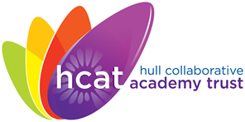
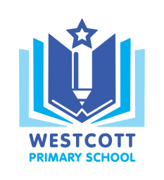
Westcott Primary School
‘Inspiring independence and a love for learning’

Westcott Street Email: admin@westcott.hull.sch.uk
Kingston upon Hull Website: www.westcottprimary.org.uk
HU8 8NB
Telephone: 01482 783576

28 March 2019
Dear parent/carer,
On Wednesday 3rd April 2019, at 14:30, we will be holding a reading workshop for parents. The aim of this event is to work with you with the shared aim of supporting our children with their reading at home. We will detail our approach to the teaching of reading, as well as the difference between the explicit teaching of reading skills and the overarching aim of developing a love of reading.
Attendees will be automatically entered in a prize draw to win a £50 reading voucher. We hope as many parents as possible can attend, to support the home reading approach at our school.
If you have any questions please do not hesitate to contact me.
Yours sincerely

Mr A Whitworth
Assistant Headteacher

