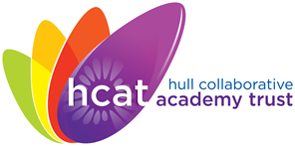
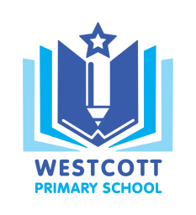
Westcott Primary School
‘Inspiring independence and a love for learning’

Westcott Street Email: admin@westcott.hull.sch.uk
Kingston upon Hull Website: www.westcottprimary.org.uk
HU8 8NB
Telephone: 01482 783576

27 February 2019

Dear parent/carer

WORLD BOOK DAY 2019

Just a reminder that World Book Day is on Thursday 7th March 2019.

As part of the celebrations and activities we are asking all the children to come school dressed as a character from a book or in non-uniform.

Your child should have received their £1 book token, please remember to use it before the end of March 2019.

Yours sincerely

Mr. A Whitworth
Assistant Headteacher and Literacy Lead

