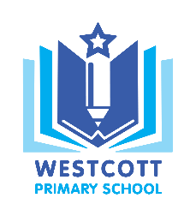
Westcott Primary School
‘Inspiring independence and a love for learning’

Westcott Street Email: admin@westcott.hull.sch.uk
Kingston upon Hull Website: www.westcott.hull.dbprimary.com
HU8 8NB
Telephone: 01482 783576

Wednesday 30th January 2019

Dear Parents/Carers

On Wednesday 13th February at 2.30 pm the Year 4 and Year 5&6 children who have continued with their music, will be putting on a performance based on the ‘Wider Opportunities’ music lessons they have been taking part in this year. We would love you to come along to the performance, which will be held in our school hall.

We look forward to seeing you.

Yours sincerely

Miss D Tague
Head teacher

Miss M Green
Year 4 Class Teacher

