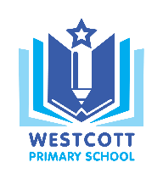
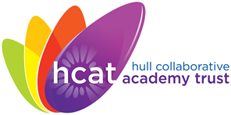
Westcott Primary School
‘Inspiring independence and a love for learning’

Westcott Street Email: admin@westcott.hull.sch.uk
Kingston upon Hull Website: www.westcott.hull.dbprimary.com
HU8 8NB
Telephone: 01482 783576

18th December 2018

Dear Parents/Carers

In the New Year the cost of school meals is to rise to £1 per meal for pupils aged 7-11 years. Although no-one wants to see price increases, the reason for this is simple.
Currently all pupils aged 4-7 years receive universal free school meals. When pupils reach Year 3 parents have to pay and Hull school meals are among the lowest priced in the country at 50p per meal for 7-11 year olds. This is considerably lower than our neighbours in the East Riding. Hull Primary schools are subsidising the cost of paid meals by, on average, 88p a day per meal. This may not seem much but this cost soon mounts up and could be anywhere between £18,000 and £90,000 a year. These huge sums of money are better spent in school providing your child with the very best learning opportunities and support.
As a result Hull Primary Schools have asked Hull City Council to allow us to raise the cost per meal to £1 and to help us to ensure as many pupils are registered to receive free school meals as are eligible to get them. Claiming free school meals means additional funding comes into your child’s school, which can be spent on education.
We appreciate this may affect those of you on low incomes and we impose it with the greatest reluctance, but assistance is available for families and, of course, this is handled discretely and confidentially.
If you are in receipt of one of the benefits below and have not already applied for free school meals for your child, you can save money and ensure your child’s school is able to maximise its funding, by applying today. Please check the list below to see if you may qualify.
Are you in receipt of:
- Income support?
- Income based jobseekers allowance?
- Income related employment and support allowance (ESA – IR)?
- Universal credit?
- Asylum seekers (receiving support under Part VI of the Immigration and Asylum Act 1999)?
- The guaranteed element of state pension credit?
- Child tax credit (with an annual income of no more than £16,190 as assessed by the Inland Revenue)?
- Working tax credit run on - paid for four weeks after you stop qualifying for working tax credit?

It is a straightforward process to apply and can be done on-line – using the following link
http://www.hull.gov.uk/education-and-schools/schools/free-school-meals
Alternatively it can be sorted out when your child is next in school. Even if your child is aged 4-7 years old or doesn’t take up the free meals provision, knowing about them generates much needed extra funding.
Have you been eligible for free school meals at any time since May 2012 even if you no longer claim for it? It is worth your while checking with the school to see if they are receiving the funding your child is entitled to.
Thank you for your support in this matter. Your school is there to support you during this and can help you fill in any paperwork to claim free school meals. They are also very happy to check on your entitlement to ensure your child isn’t missing any valuable funding.
Yours Sincerely

Miss D Tague
Head teacher

