Autumn Term – Y3
Think Big
Science

Year 3 and 4 - Working scientifically

I can ask relevant scientific questions.
I can use observations and knowledge to answer scientific questions.
I can set up a simple enquiry to explore a scientific question.
I can set up a test to compare two things.
I can set up a fair test and explain why it is fair.
I can make careful and accurate observations, including the use of standard units.
I can use equipment, including thermometers and data loggers to make measurements.
I can gather, record, classify and present data in different ways to answer scientific questions.
I can use diagrams, keys, bar charts and tables; using scientific language.
I can use findings to report in different ways, including oral and written explanations, presentations.
I can draw conclusions and suggest improvements.
I can make a prediction with a reason.
I can identify differences, similarities and changes related to an enquiry.

Year 3- Animals, including hum
I can understand that animals, including humans, need the right types and amount of nutrition, and that they cannot make their own food; they get nutrition from what they eat.
I can explain that humans and some other animals have skeletons and muscles for support, protection and movement.
Activity

Looking at how and what the biggest animals on Earth eat.

Year3 – Sound
I can describe how a sound is made.
I can explain how a sound travels from the source to our ears.
I can explain the place of vibration in hearing.
I can explore the correlation between pitch and the object producing the sound.
I can explore the correlation between the volume of a sound and the strength of the vibrations that produce it.
I can describe what happens to a sound as it travels away from its source.

Activity
Looking at how whales produce sound and why it travels so far.

History
Year 3
I can describe events in the past using the dates for when things happened.
I can use a timeline within a specific period of history and set out the order that things may have happened.
I can use my mathematical knowledge to work out how long ago events happened.

Activity

History of space exploration timelines (Computing) Greek inventions and The Trojan War.
Whaling & Local Study

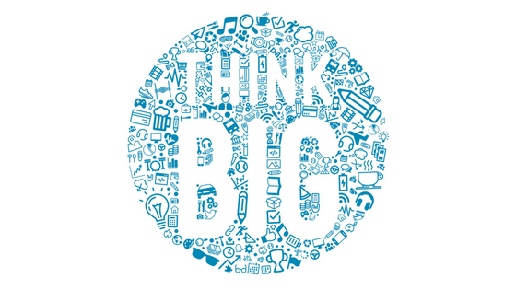

Projects

LAUNCH: Art sculptures – planets.

TRIP: Magma museum/Maritime museum.

CELEBRATION: Gingerbread creations – bake off!

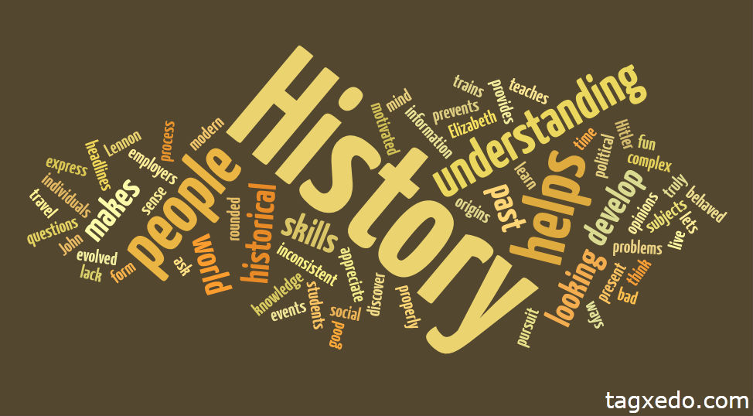


PE
Year 3

NAPA – Ballet (dance)

I can take the lead when working with a partner or a group.
I can use dance to communicate an idea.

Activity

Sequences choreographed to tracks from The Greatest Showman.

Art

Year 3

I can use a range of brushes to create different effects in painting.

Activity

Sculpture- papier-mâché model planets (launch day).

RE

Objectives within the ER 2016 Agreed Syllabus.



Music

Year 3

I can sing a tune with expression.
I can use musical words to describe a piece of music and composition.
I can use musical words to describe what I like and do not like about a piece of music.
I can improve my work; explaining how it has been improved.

Activity

Dragon song.
Compose own sea shanty linked to whaling ships in Hull.

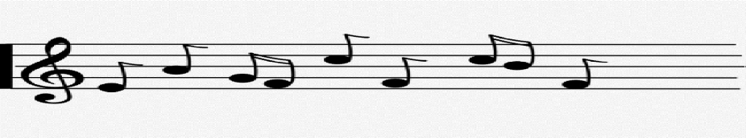
French
Year 3
Spoken language
- I can have a short conversation saying 3-4 things.
- I can give a response using a short phrase.
- I am starting to speak in sentences.
Reading
- I can use a bilingual dictionary or glossary to look up new words.
- I can read and understand a short passage using familiar language.
- I can explain the main points in a short passage.
Writing
- I can write phrases from memory.
- I can write 2-3 short sentences on a familiar topic.
- I can say what I like/dislike about a familiar topic.

DT
Year 3
I can prove that my design meets some set criteria.
I can follow a step-by-step plan, choosing the right equipment and materials.
I can design a product and make sure that it looks attractive.
I can select the most appropriate tools and techniques for a given task.
I can describe how food ingredients come together.
I can work accurately to measure and make cuts.

Activity

Gingerbread model

Computing
Year 3
Information technology
I can design and create content.
I can collect information.
I can manipulate and improve digital images.

Digital Literacy
I can use technology respectfully and responsibly.

Activity

App smash to present learning combining a variety of apps.
Creating an interactive book on space and the solar system.
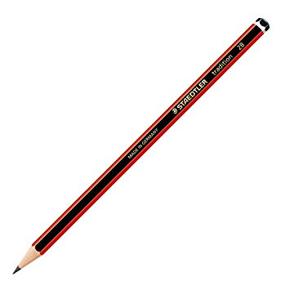

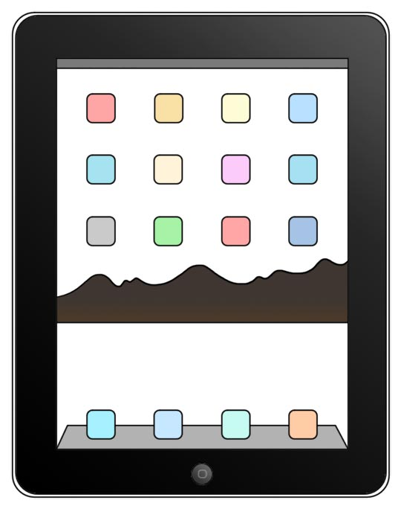

Geography
Year 3

I can use an atlas by using the index to find places.
I can use the correct geographical words to describe a place.
I can use grid references on a map.
I can name a number of countries in the northern hemisphere.
I can name and locate the capital cities of neighbouring European countries.

Activity
Finding the locations of the worlds biggest things, e.g. mountains and rivers etc…

PSHE

Is taught through other subjects, whole school activities and classroom: personal change zone and character virtues.

